

**Become a member**

H**ISTORY**

Over a two-year period in the late nineties, Townsville musicians, arts workers and a group of people who had a love for music realised the potential for developing a community-based Orchestra — one that would flourish and become an integral part of the City’s cultural life.

In 2000 to ‘test’ the viability of establishing an Orchestra a weekend workshop was arranged and musicians were invited to participate under the baton of Richard McIntyre, Senior Lecturer at the Canberra School of Music and the result — the Barrier Reef Orchestra was born.

Sign Up

**Read about our artists**

**`**

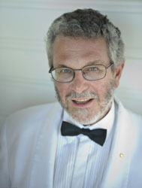

Copyright 2017